**Project Name: OCEAN SCHEDULE - POC**

**Document Version: 1.0**

**Creation Date: 21-Aug-24**

**Table of Contents**

PURPOSE 3

SCOPE 3

DEFINITIONS 3

BUSINESS REQUIREMENTS 3

NON-FUNCTIONAL REQUIREMENTS 4

INTERFACE REQUIREMENTS 5

USE CASES 5

DOCUMENT CONTROL 6

Document Version 6

Document Approval 6

Document Change Control 6

References 6

# PURPOSE

To build sailing schedule as a product that helps customers to get the feeds of ocean carrier schedules.

# SCOPE

While we wanted to build ocean schedule as a product, we will need to execute Proof of concept for Top 10 ocean carriers by extracting the schedules from their respective website.

# BUSINESS REQUIREMENTS

To create component to scrap the ocean schedules from the respective carrier website. In order to provide ocean schedule feed to the customer, we will need to first test the scrapping capabilities from the carrier website.

# MSc

Website : <https://www.msc.com/en/search-a-schedule>

1. 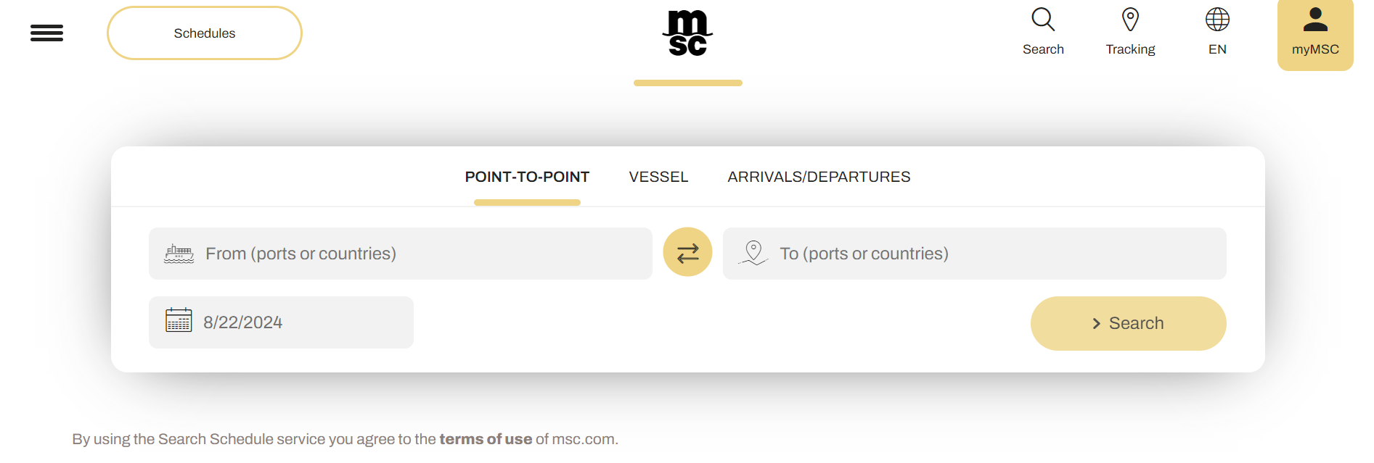

In Pont-To-Point – input From as Port of Loading (eg. Nhava sheva) and To as Port of Discharge (eg. Jebel Ali) and date will come by default as today’s date. If required, we can change the date of departure to fetch the ocean schedules. By clicking on the search, system will show next available ocean schedules.

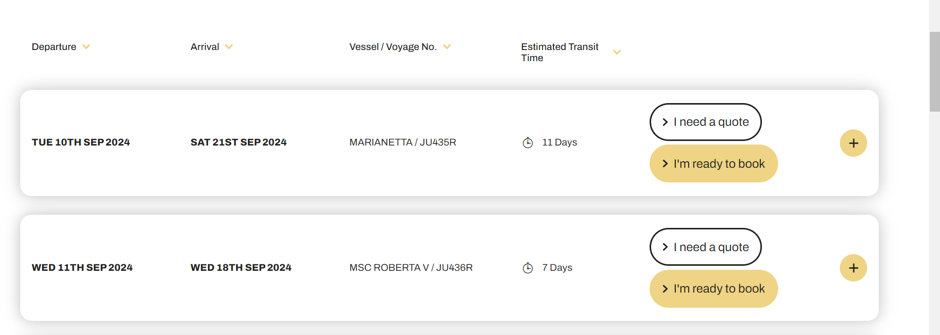

Initially it shows ETD, ETA, Vessel/voyage and Transit days. If we want to see the details of the particular schedule, click on the + icon.

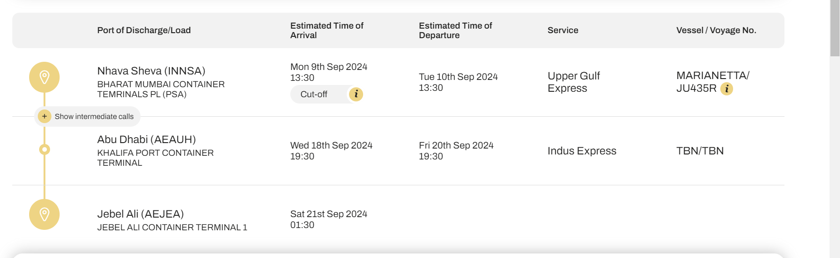

From here we can pull movement details alongside with cutoff dates. Click on the “I” symbol to pull all the cutoff dates for the particular schedule.

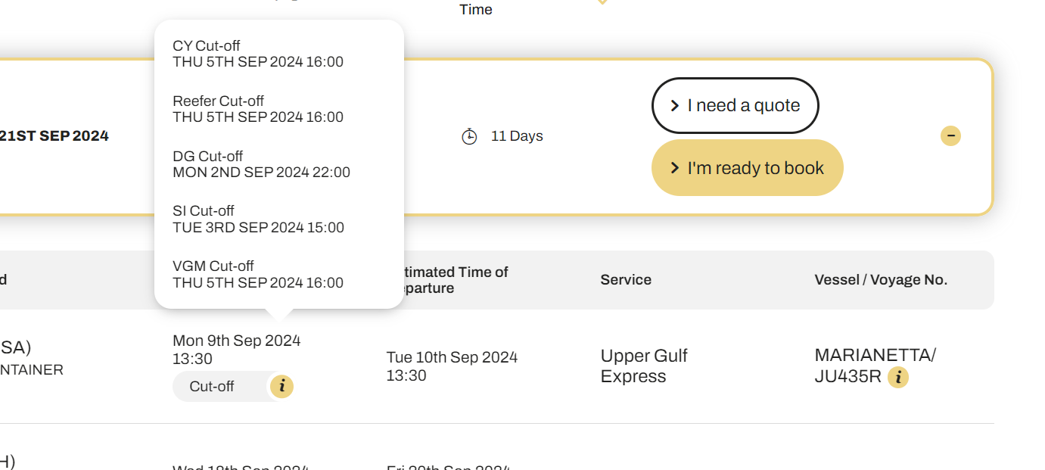

For the purpose of completing POC, please pull the below details from the MSc website

1. ETD (ETD)
2. ETA (ETA)
3. Vessel name (Vessel)
4. Voyage no (Voyage)
5. CY Cutoff (Port Cutoff)
6. SI Cutoff ( Docs Cutoff)

# ONEY

Website : <https://ecomm.one-line.com/one-ecom/schedule/point-to-point-schedule>

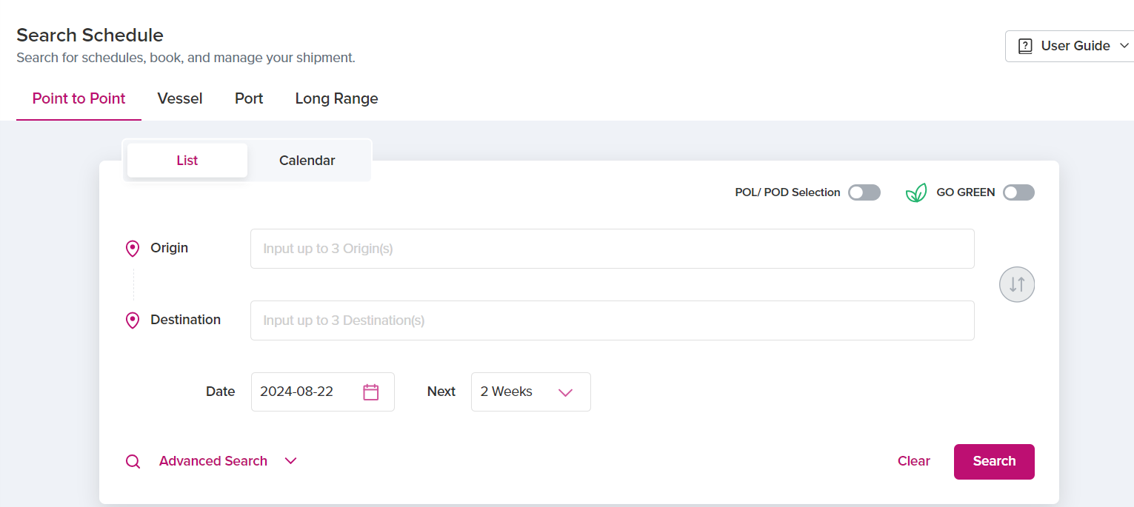

In Pont-To-Point – input Origin as Port of Loading (eg. Nhava sheva) and Destination as Port of Discharge (eg. Jebel Ali) and date will come by default as today’s date. If required, we can change the date of departure to fetch the ocean schedules. In Next we can select whether to pull next 2 weeks schedule or 4 weeks schedule from the departure date. By clicking on the search, system will show available ocean schedules.

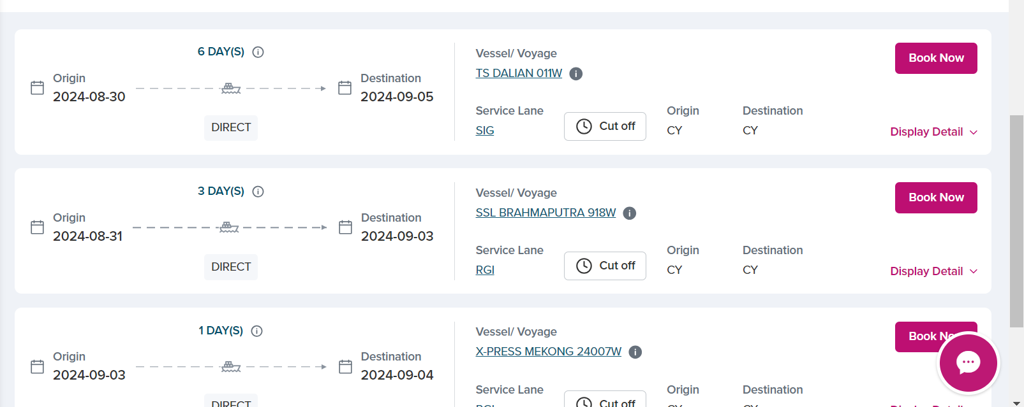

From here we can pull movement details alongside with cutoff dates. Click on the “Cutoff” to pull all the cutoff dates for the particular schedule.

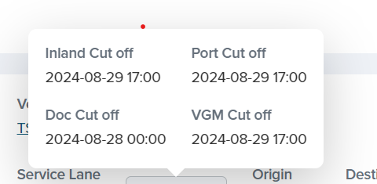

For the purpose of completing POC, please pull the below details from the ONEY website

1. ETD (ETD)
2. ETA (ETA)
3. Vessel name (Vessel)
4. Voyage no (Voyage)
5. Port Cutoff (Port Cutoff)
6. Doc Cutoff (Docs Cutoff)

# EVERGREEN

Website : <https://ss.shipmentlink.com/tvs2/jsp/TVS2_InteractiveSchedule.jsp>

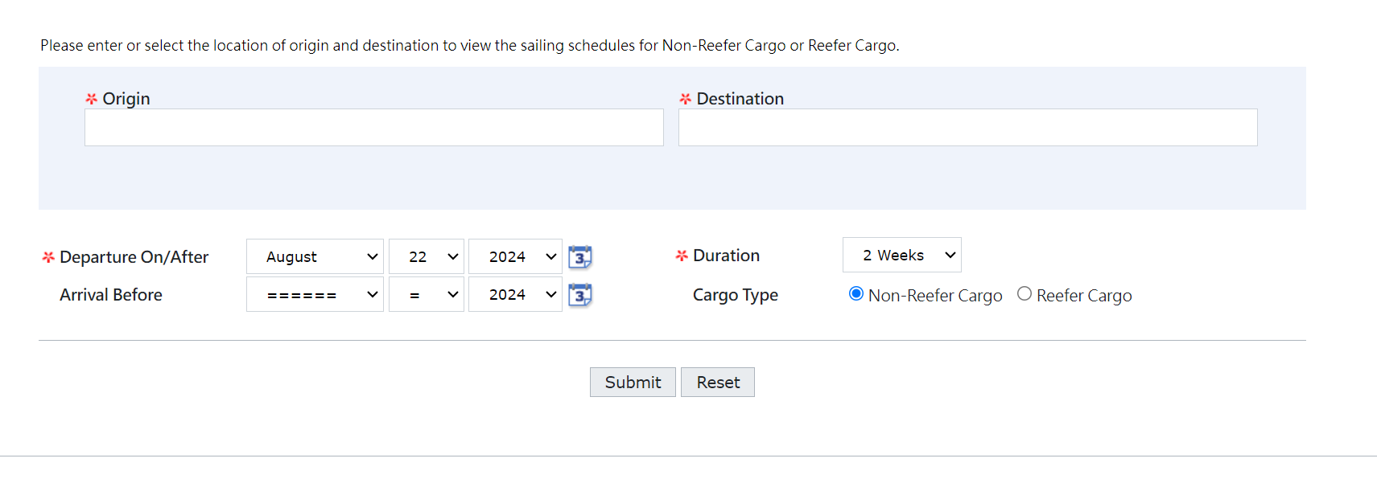

Input Origin as Port of Loading (eg. Nhava sheva) and Destination as Port of Discharge (eg. Jebel Ali) and Departure on/after will come by default as today’s date. If required, we can change the date of departure to fetch the ocean schedules. In Duration we can select whether to pull next 2 weeks’ schedule or 4 weeks schedule from the departure date respectively. By clicking on the submit, system will show available ocean schedules.

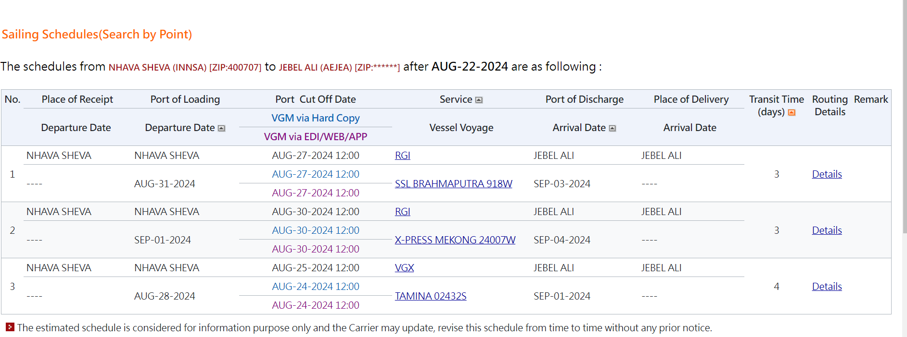

From here we can pull movement details alongside with cutoff dates.

For the purpose of completing POC, please pull the below details from the Evergreen website

1. ETD from Departure Date (ETD)
2. ETA from Arrival Date (ETA)
3. Vessel name (Vessel)
4. Voyage no (Voyage)
5. Port Cutoff (Port Cutoff)
6. empty (Docs Cutoff)

# Maersk

Website : <https://www.maersk.com/schedules/pointToPoint>

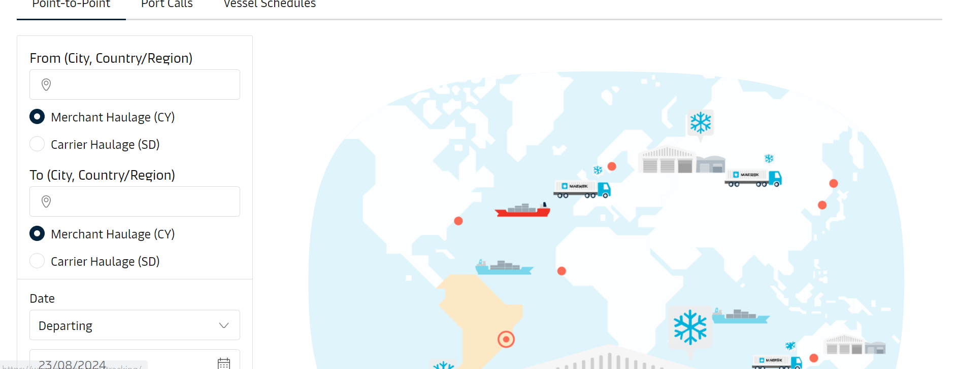

In Point-to-Point - Input From as Port of Loading (eg. Nhava sheva) and To as Port of Discharge (eg. Jebel Ali) and Date will come by default as today’s date. If required, we can change the date of departure to fetch the ocean schedules. By clicking on the submit, system will show available ocean schedules.

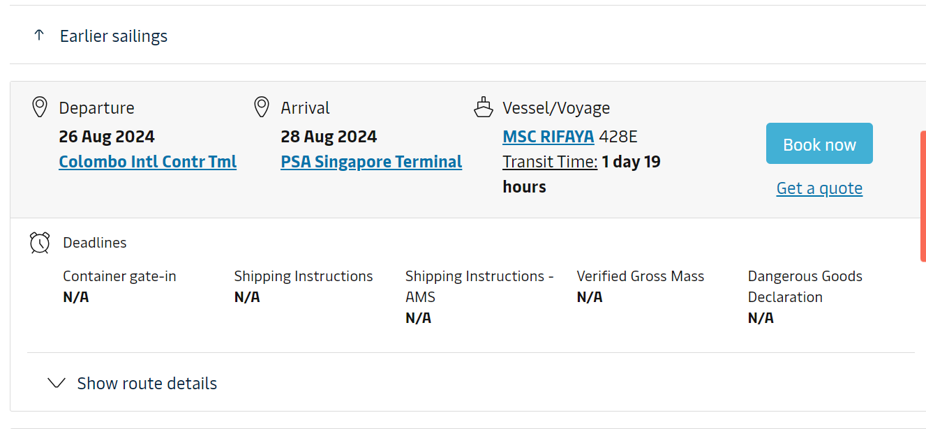

From here we can pull movement details alongside with cutoff dates.

For the purpose of completing POC, please pull the below details from the Maersk website

1. ETD from Departure Date (ETD)
2. ETA from Arrival Date (ETA)
3. Vessel name (Vessel)
4. Voyage no (Voyage)
5. Container Gate-in (if its shows N/A leave this column empty) (Port Cutoff)
6. Shipping Instructions (if its shows N/A leave this column empty) (Docs Cutoff)

# CMA-CGM

Website : <https://www.cma-cgm.com/ebusiness/schedules>

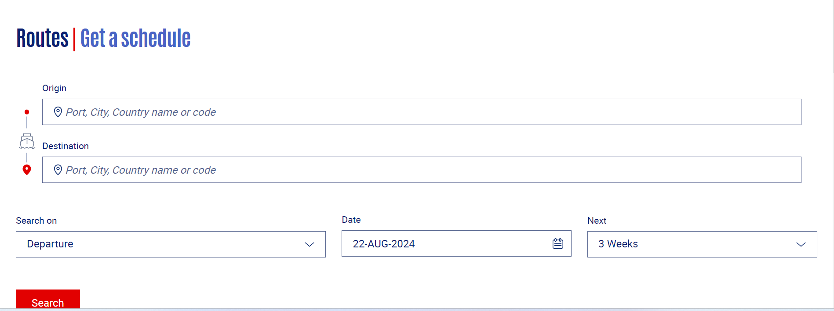

Input Origin as Port of Loading (eg. Nhava sheva) and To as Port of Discharge (eg. Jebel Ali) and Date will come by default as today’s date. If required, we can change the date of departure to fetch the ocean schedules. In Next, we can choose no of weeks to pickup the schedule schedule from the date of departure. clicking on the Search will show available ocean schedules.

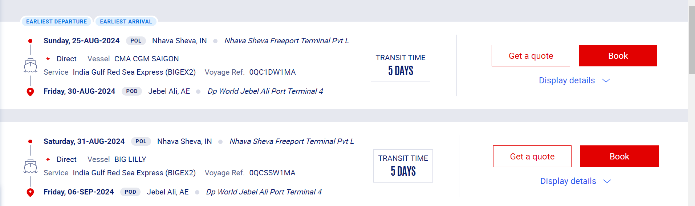

From here click on the Display details to see movement details alongside with cutoff dates.

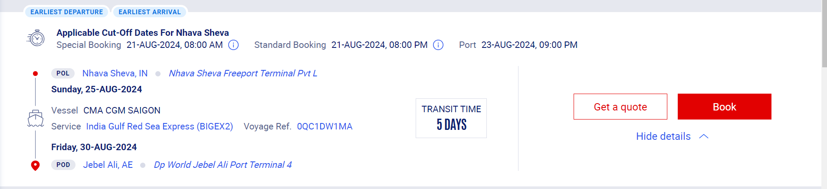

For the purpose of completing POC, please pull the below details from the CMACGM website

1. ETD from date below POL (ETD)
2. ETA from date below POD (ETA)
3. Vessel name (Vessel)
4. Voyage no (Voyage)
5. Port cutoff (Port Cutoff)
6. empty (Docs Cutoff)

# Hapag

Website : <https://www.hapag-lloyd.com/en/online-business/schedule/interactive-schedule/interactive-schedule-solution.html>

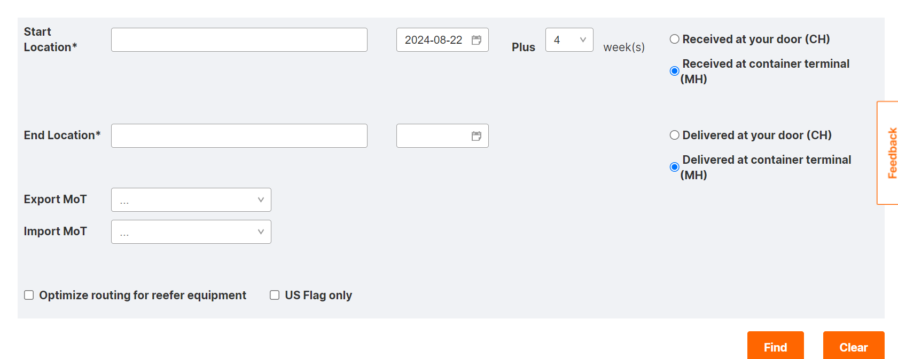

Input Start Location as Port of Loading (eg. Nhava sheva) and End Location as Port of Discharge (eg. Jebel Ali) and Date will come by default as today’s date. If required, we can change the date of departure to fetch the ocean schedules. In Plus, we can choose no of weeks to pickup the schedule schedule from the date of departure. clicking on the Search will show available ocean schedules.

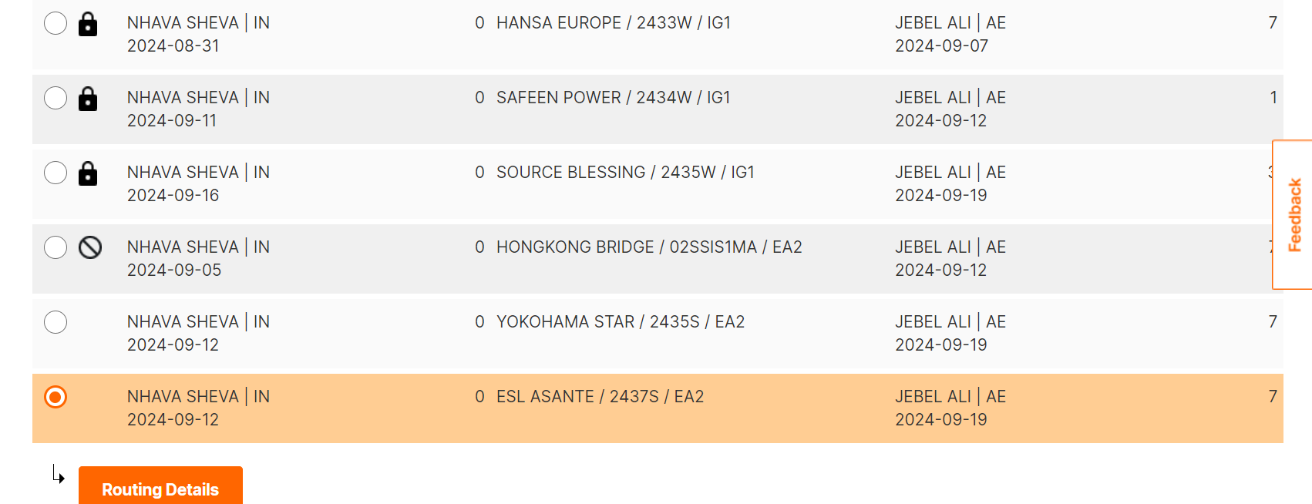

Select the particular schedule and click on the Routing details to see movement details alongside with cutoff dates.

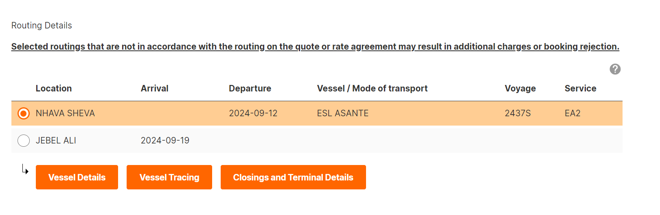

Here Select location as POL and click on Closing and Terminal Details to see the cutoff dates.

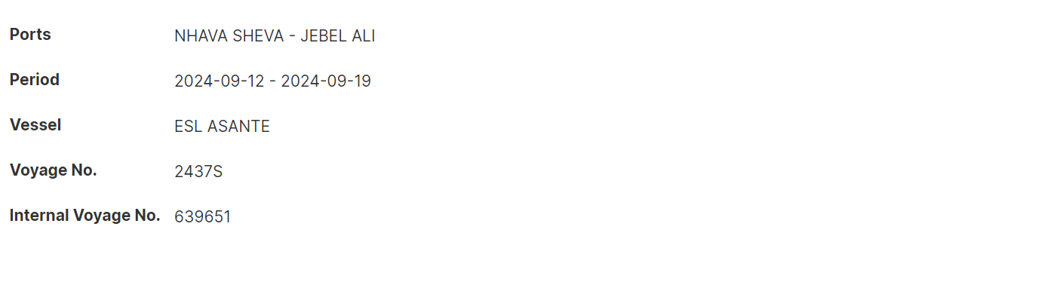

For the purpose of completing POC, please pull the below details from the Hapag website

1. ETD from date below POL (ETD)
2. ETA from date below POD (ETA)
3. Vessel name (Vessel)
4. Voyage no (Voyage)
5. Port cutoff (Port Cutoff)
6. empty (Docs Cutoff)

# HMM

Website : <https://www.hmm21.com/e-service/general/schedule/ScheduleMain.do>

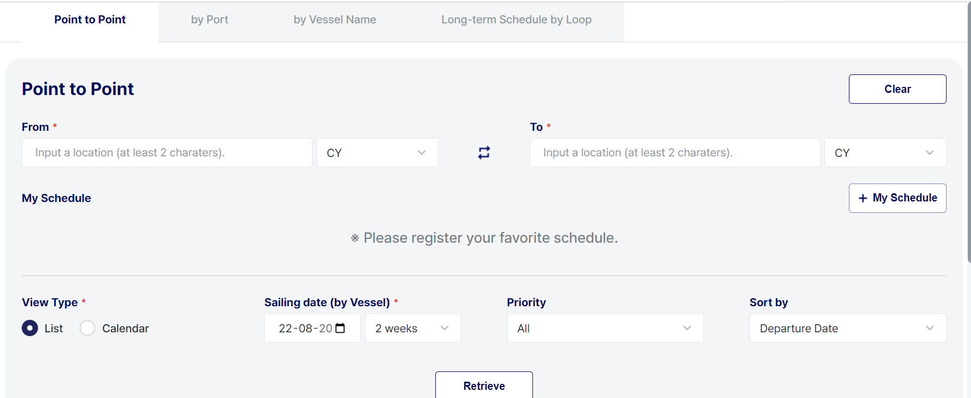

In Point to Point - Input From as Port of Loading (eg. Nhava sheva) and To as Port of Discharge (eg. Jebel Ali) and Sailing Date will come by default as today’s date. If required, we can change the date of departure to fetch the ocean schedules. clicking on the Retrieve will show available ocean schedules.

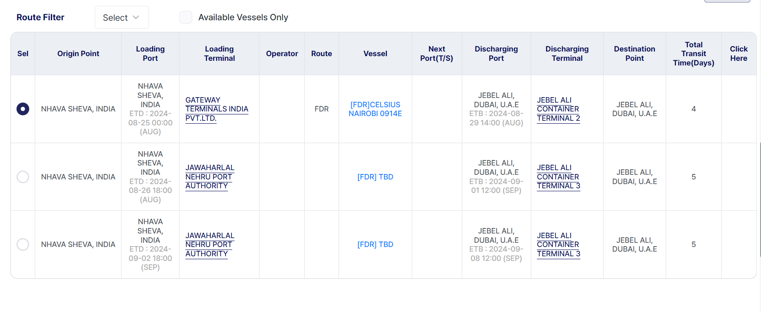

From here click on particular schedule to see movement details alongside with cutoff dates.

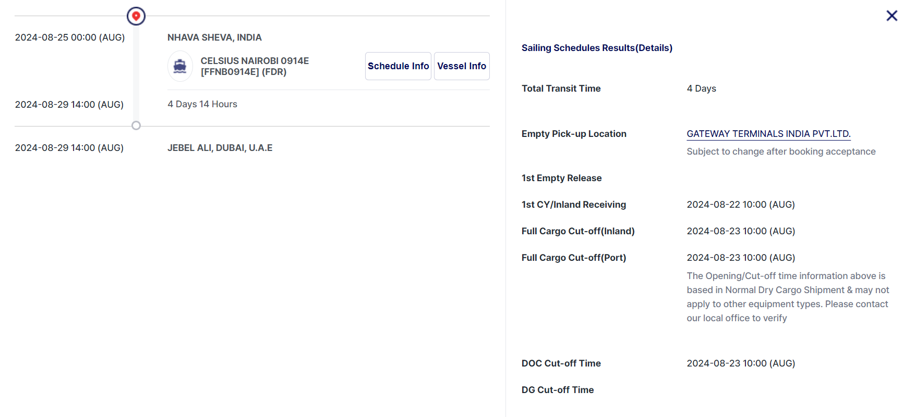

For the purpose of completing POC, please pull the below details from the CMACGM website

1. ETD from date below POL (ETD)
2. ETA from date below POD (ETA)
3. Vessel name (Vessel)
4. Voyage no (Voyage)
5. Full Cargo Cut-off Port (Port Cutoff)
6. Doc Cut-off Time (Docs Cutoff)

# ZIM

Website : <https://www.zim.com/schedules>

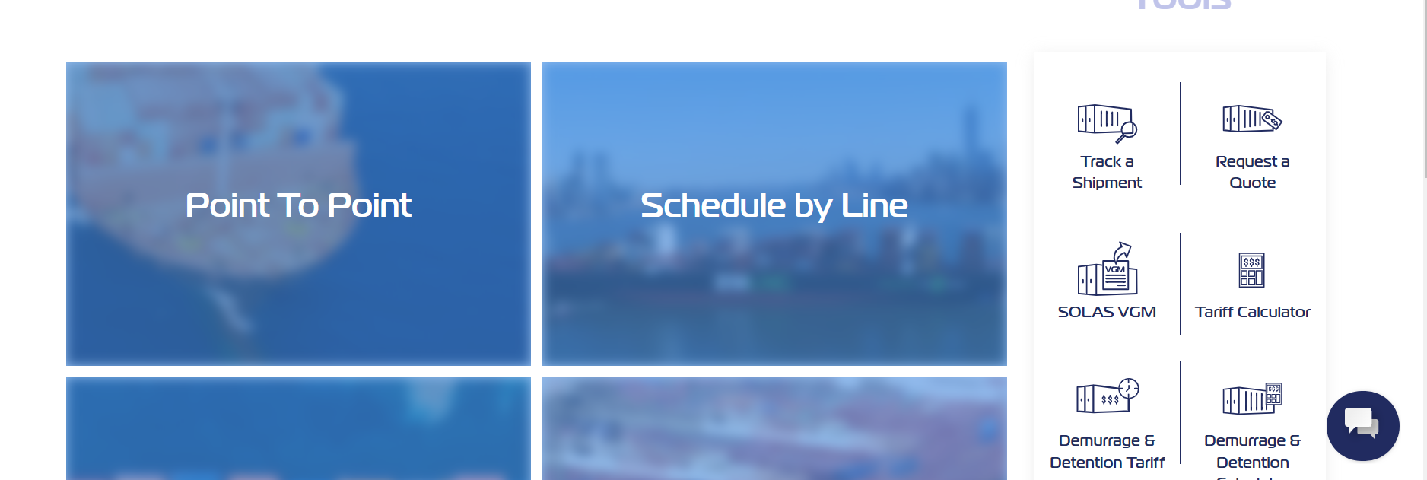

From here click on Point To Point to pull the schedules by tradelane.

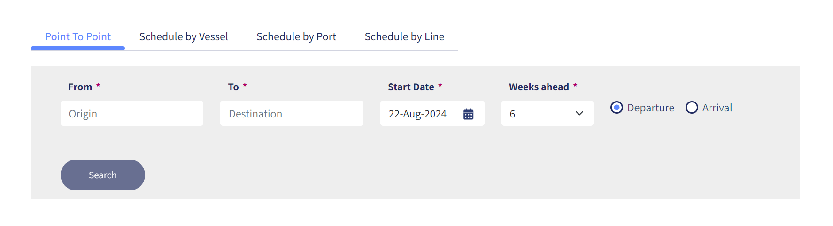

In Point to Point - Input From as Port of Loading (eg. Nhava sheva) and To as Port of Discharge (eg. Jebel Ali) and Sailing Date will come by default as today’s date. If required, we can change the date of departure to fetch the ocean schedules. In Weeks ahead select no of weeks to pull the schedules from the departure date and clicking on the Search will show available ocean schedules.

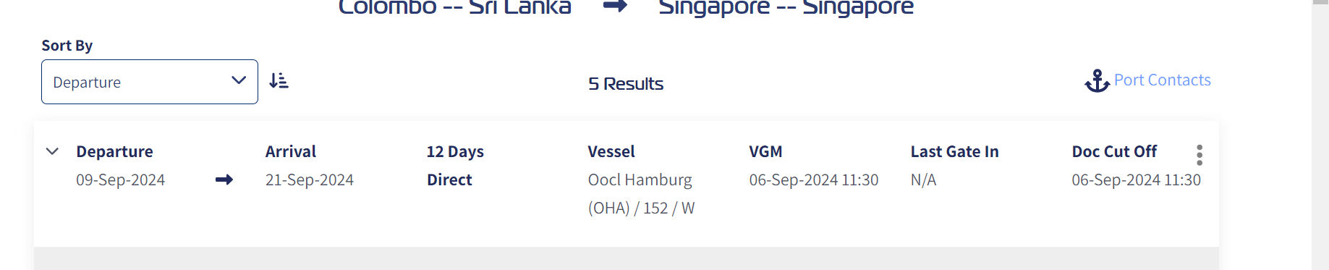

For the purpose of completing POC, please pull the below details from the CMACGM website

1. Departure (ETD)
2. Arrival (ETA)
3. Vessel name (Vessel)
4. Voyage no (Voyage)
5. Last Gate-in (Port Cutoff)
6. Doc Cut-off Time (Docs Cutoff)

# YANGMING

Website : <https://www.yangming.com/e-service/schedule/PointToPoint.aspx>

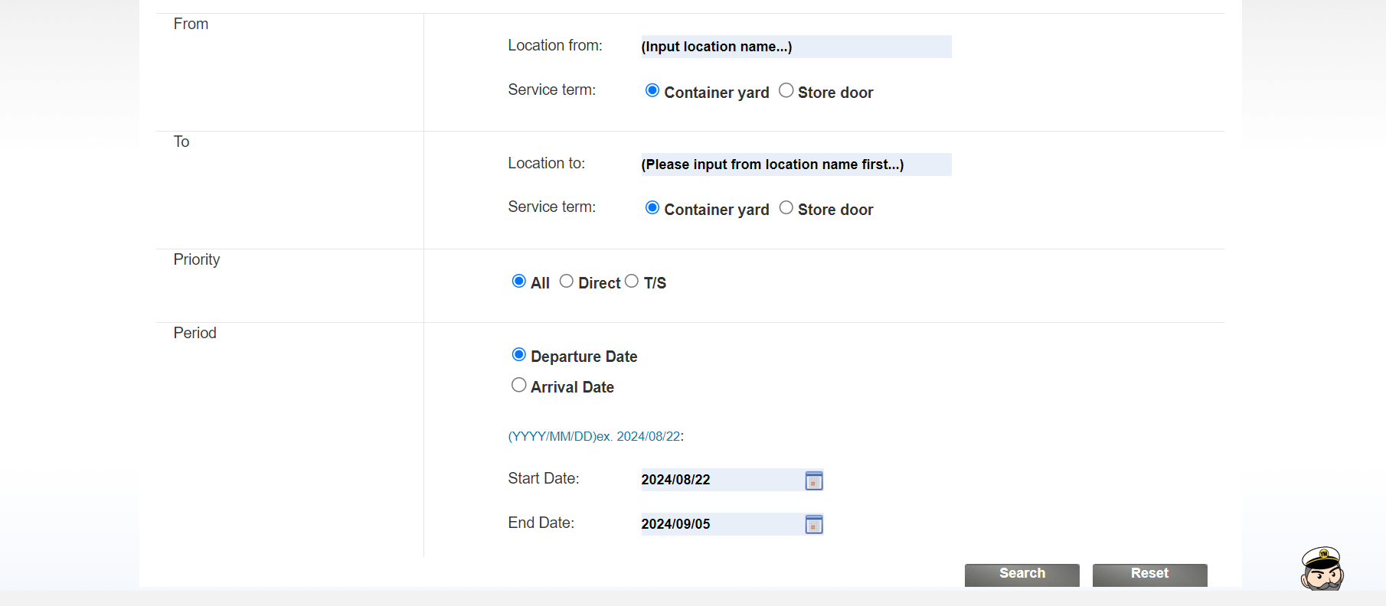

Input From as Port of Loading (eg. Nhava sheva) and To as Port of Discharge (eg. Jebel Ali) and Select Start and End Date to pickup ocean schedules departing within the date range. clicking on the Search will show available ocean schedules.

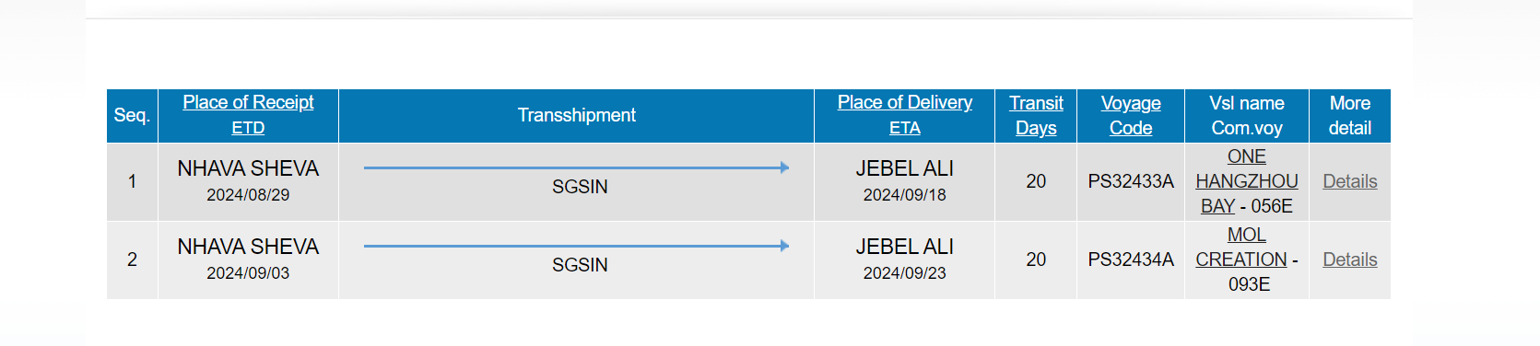

From here click on more details to see movement details alongside with cutoff dates.

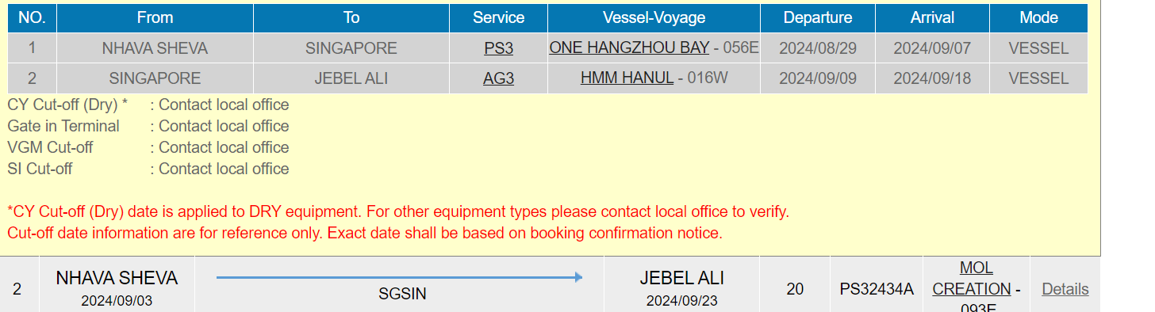

For the purpose of completing POC, please pull the below details from the CMACGM website

1. ETD from date below Port of Receipt (ETD)
2. ETA from date below Place of Delivery (ETA)
3. Vessel name (Vessel)
4. Voyage no (Voyage)
5. CY Cutoff (Port Cutoff)
6. SI Cutoff (Docs Cutoff)

# NON-FUNCTIONAL REQUIREMENTS

# INTERFACE REQUIREMENTS

# USE CASES

# ASSUMPTIONS

# CONSTRAINTS

# DOCUMENT CONTROL

## Document Version

| **Version** | **Date** | **Author** | **Change** |
| --- | --- | --- | --- |
| 1.0 | 21-Aug-2024 | Suresh MS |  |
|  |  |  |  |

## Document Approval

This plan is approved by the persons named below. Signatures are on file.

| **Title** | **Name** | **Approval Date** |
| --- | --- | --- |
|  |  |  |

## Document Change Control

This document is under the control of the Project Manager. Change requests or updates are submitted to the Project Manager for consideration. The approvers listed above will consider and approve document revisions.